Go to this link: https://github.com/Giacomix02/Re_Discover/releases

Click on Assets
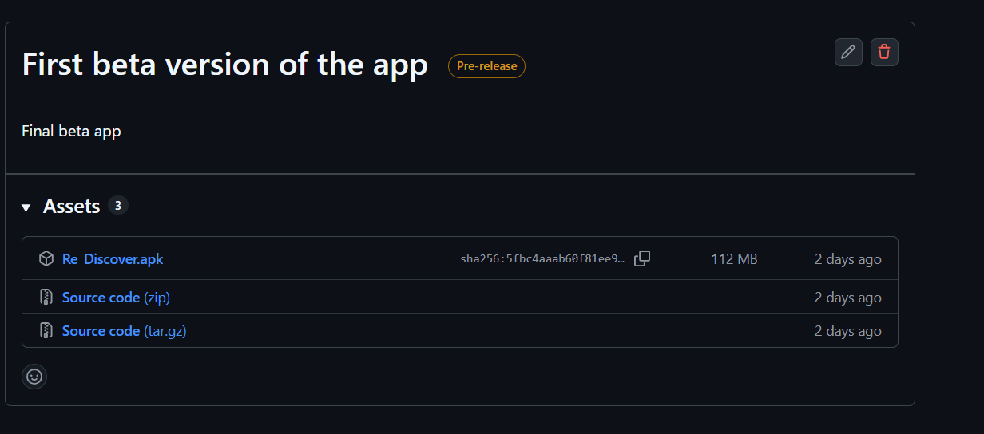

Click on “Re_Discover.apk”, the download must start in seconds
After the download go to the Download folder and click the file

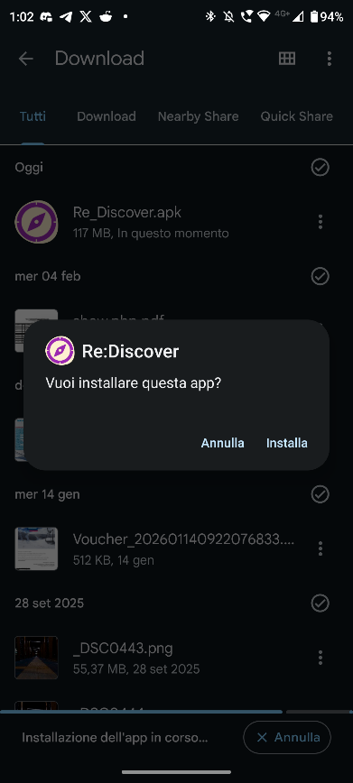
Follow the instructions prompted by your device.
If needed you must give the permission to install “External app”, but don’t worry, it’s all a guided process
After the installation search and click the app

